Report on the Literary Meet
Theme: “Ink of Integrity”
Organised by: Departments of English and Bengali
In collaboration with: Department of Bengali, Kandi Raj College, Department of English, Domkal Girls’ College, under the patronage of Internal Quality Assurance Cell, Berhampore College.
Date: 11.02.2026
Venue: Nazrul Manch, Berhampore College.
International Literary Meet on the theme “Ink of Integrity” was jointly organised by the Departments of English and Bengali of Berhampore College with great enthusiasm and academic commitment on 11th February 2026. The event aimed to celebrate literature as a powerful medium of truth, ethics, and social responsibility, highlighting how the written word can uphold integrity in society.
The host of the event, respected ma’am, Prof. Moumita Ghosh began the programme by formally declaring the meet open by extending a warm welcome to the distinguished presence and ushered the gathering into the spirit of the occasion.
The event commenced with a vibrant cultural dance, alive with rhythm and tradition, which set the tone for the literary meet, gracefully ushering in the celebration of words and wisdom. The inaugural session formally began with the ceremonial lighting of the lamp, followed by the felicitation of the distinguished dignitaries and the eminent literary figures- Sir David Lee Morgan, Prof. Subodh Sarkar Sir and Dr. Jaydeep Sarangi Sir. The event then proceeded with a warm welcome address by the Principal, Dr. Indrani Basu. Respected Principal ma’am addressed the august gathering, extending a warm and gracious welcome to the esteemed guests for gracing the occasion and expressed heartfelt gratitude for enriching the meet with their wisdom and presence .She further eloquently reflected on the theme “Ink of Integrity”, underscoring the power of literature as a medium of truth, conscience, and moral responsibility. She emphasized that integrity is not merely a word written on paper but a value to be embodied in thought, expression, and action. Encouraging the students, she urged them to let their pens be guided by honesty and intellectual sincerity in all their creative and academic pursuits.
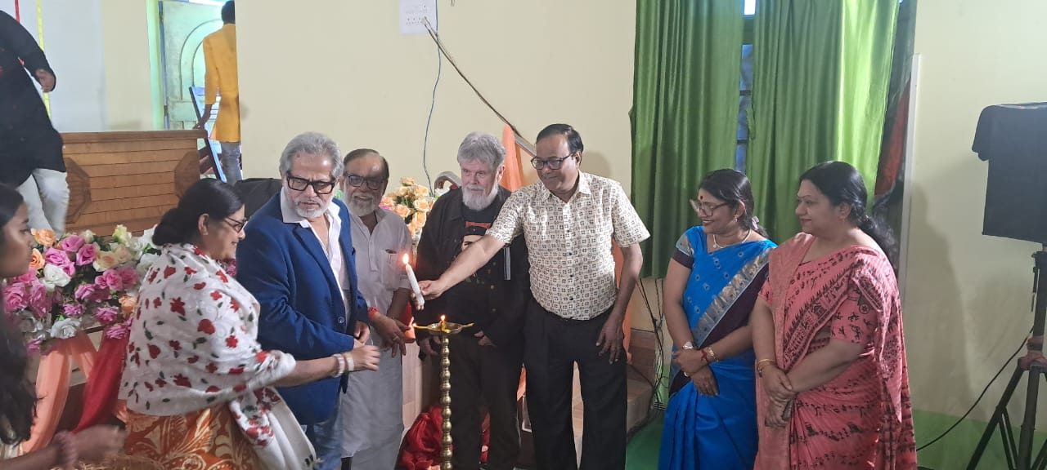
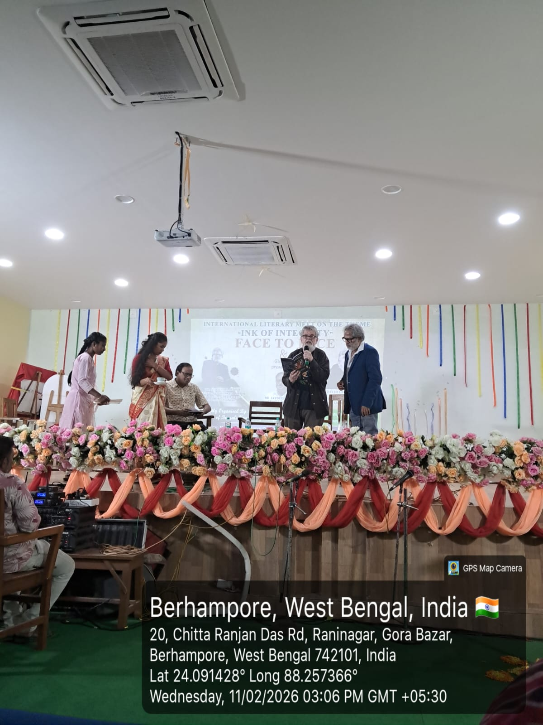
After the Principal’s inspiring speech, the event progressed with the introduction of Sir David Lee Morgan, whose remarkable contributions to literature and performance were warmly acknowledged by Ms. Shashi Preya Lama. The English Department then paid a heartfelt tribute to the legendary figure by presenting a video, capturing the depth of his poetic voice and the spirit of his artistic journey, which left the audience deeply moved and inspired.
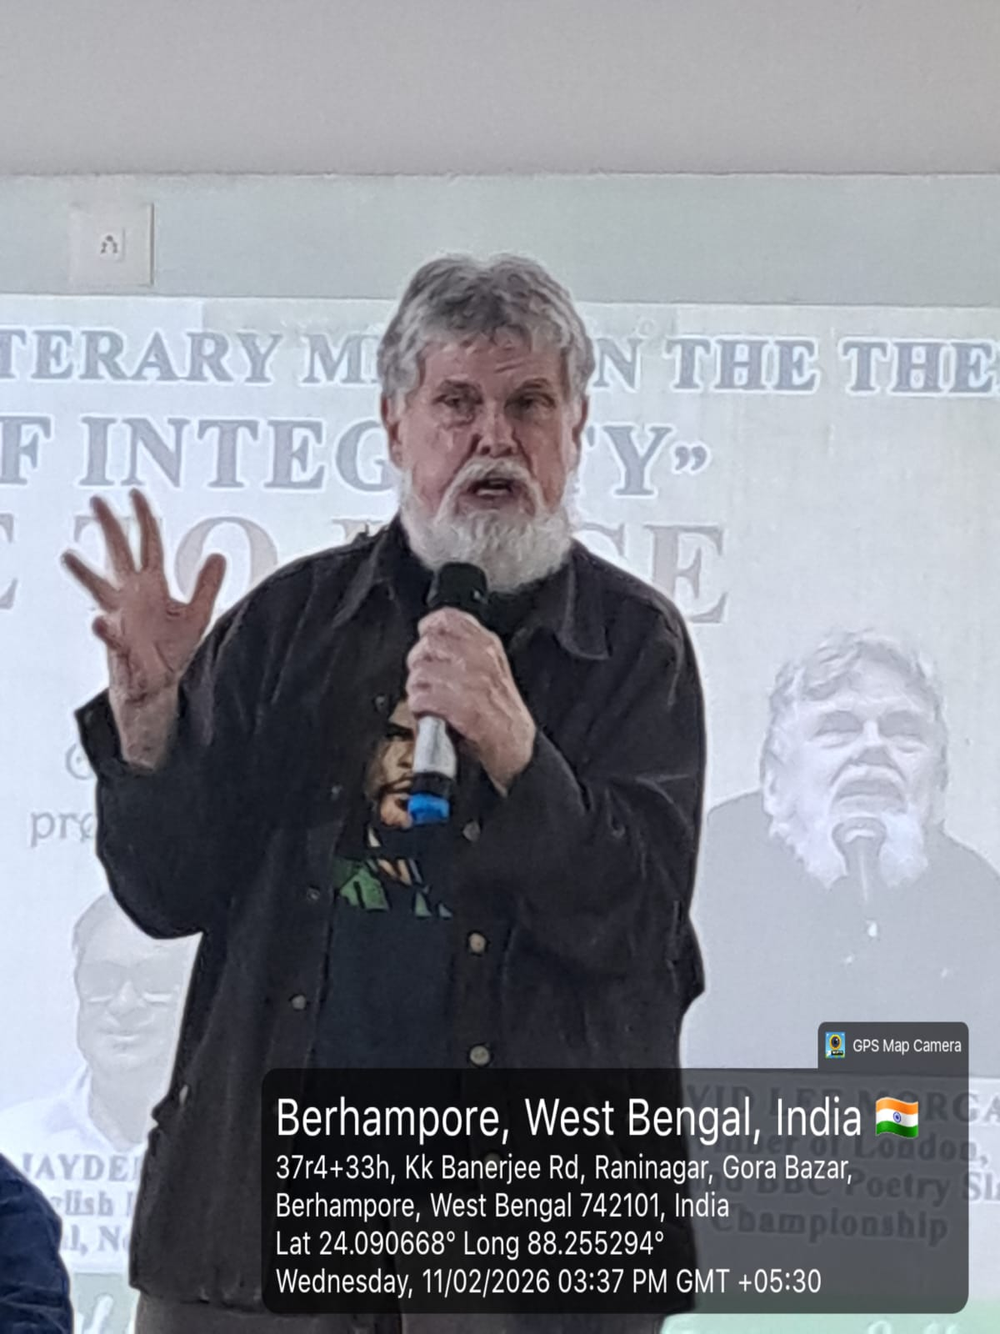
The Head of Bengali Department, Prof. Moumita Ghosh formally introduced Dr. Subodh Sarkar Sir , honouring his distinguished contribution to contemporary literature. As a mark of profound respect, a special tribute segment was organised in his honour. Students of the Bengali Department, along with Dr. Tanuka Chaudhury and Mrs. Sanchita Basu rendered expressive recitations of his poetry, reflecting remarkable depth and artistic excellence. . One of the recitations was further elevated by the soulful singing of Professor Moumita Ghosh which added a melodious and emotional dimension to the tribute. The performances created a deeply reverential atmosphere and were warmly appreciated by the audience.
The Bengali Department enriched the programme with a powerful poetry recitation on the theme Ink of Integrity, where the performers eloquently articulated the enduring bond between truth and the written word. Their evocative delivery highlighted literature as a moral compass that safeguards honesty and social conscience.
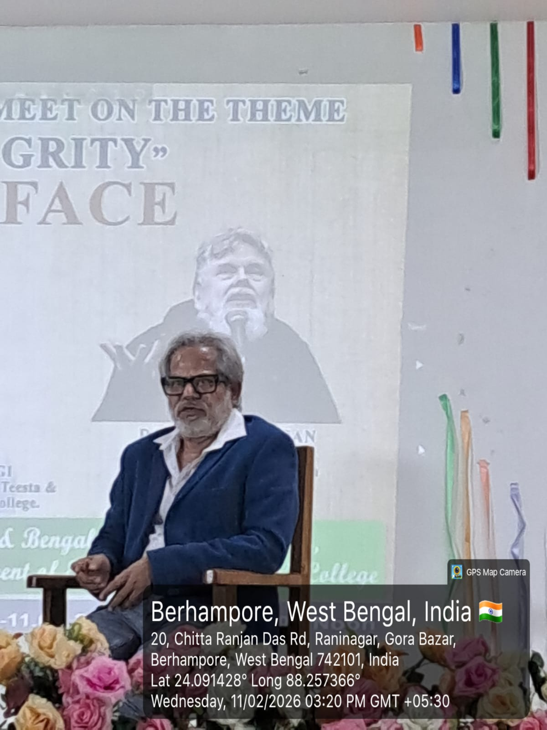
Prior to the students of English Department taking the stage, the programme featured a special segment where distinguished literary figure, Dr, Jaydeep Sarangi Sir was formally introduced to the audience, with a comprehensive overview of his life and illustrious creative journey by Ms. Shashi Preya Lama. As his achievements and literary contributions were highlighted, a thoughtfully curated slide presentation and video played in the background, vividly capturing the milestones of his artistic career. The tribute continued with a special presentation of his poetry, accompanied by a voiceover rendered by Ms. Shashi Preya Lama and Mrs. Raina Sarkar that lent a touching and respectful dimension to the tribute.
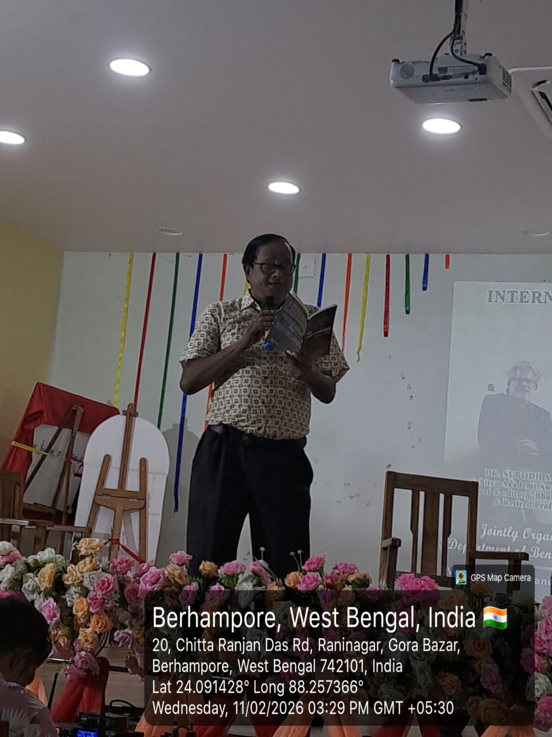
The meet featured a range of literary activities including poetry and essay writing competition, poetry recitation, dialogical poetry recitation and thematic board presentations in both English and Bengali. Thematic board display by the English Department showcased North-Eastern Indian writers, aligning their literary vision with the spirit of Ink of Integrity. To encourage excellence, a cash prize was instituted for the winners of poetry writing and essay writing competition.
The literary ambience deepened as students of English Department presented soulful poetry recitations centered on the theme Ink of Integrity, reflecting the power of words as vessels of truth and moral courage. Poetry becomes even more alive when its creator listens with the audience. The students had the privilege to recite poetries by Sir David Lee Morgan Sir and Dr. Jaydeep Sarangi Sir in their presence. Through expressive articulation and emotive delivery, the reciters brought alive the essence of integrity—where ink becomes a silent witness to conscience and conviction.
The dialogical poetry recitation by the students of English Department added a distinctive dimension, presenting integrity through a compelling exchange of voices. The synchronized performance and expressive delivery made it one of the most engaging segments of the event.
Students participated wholeheartedly, demonstrating creativity, confidence, and critical insight. Their performances and presentations reflected a deep understanding of ethical values and the social relevance of literature.

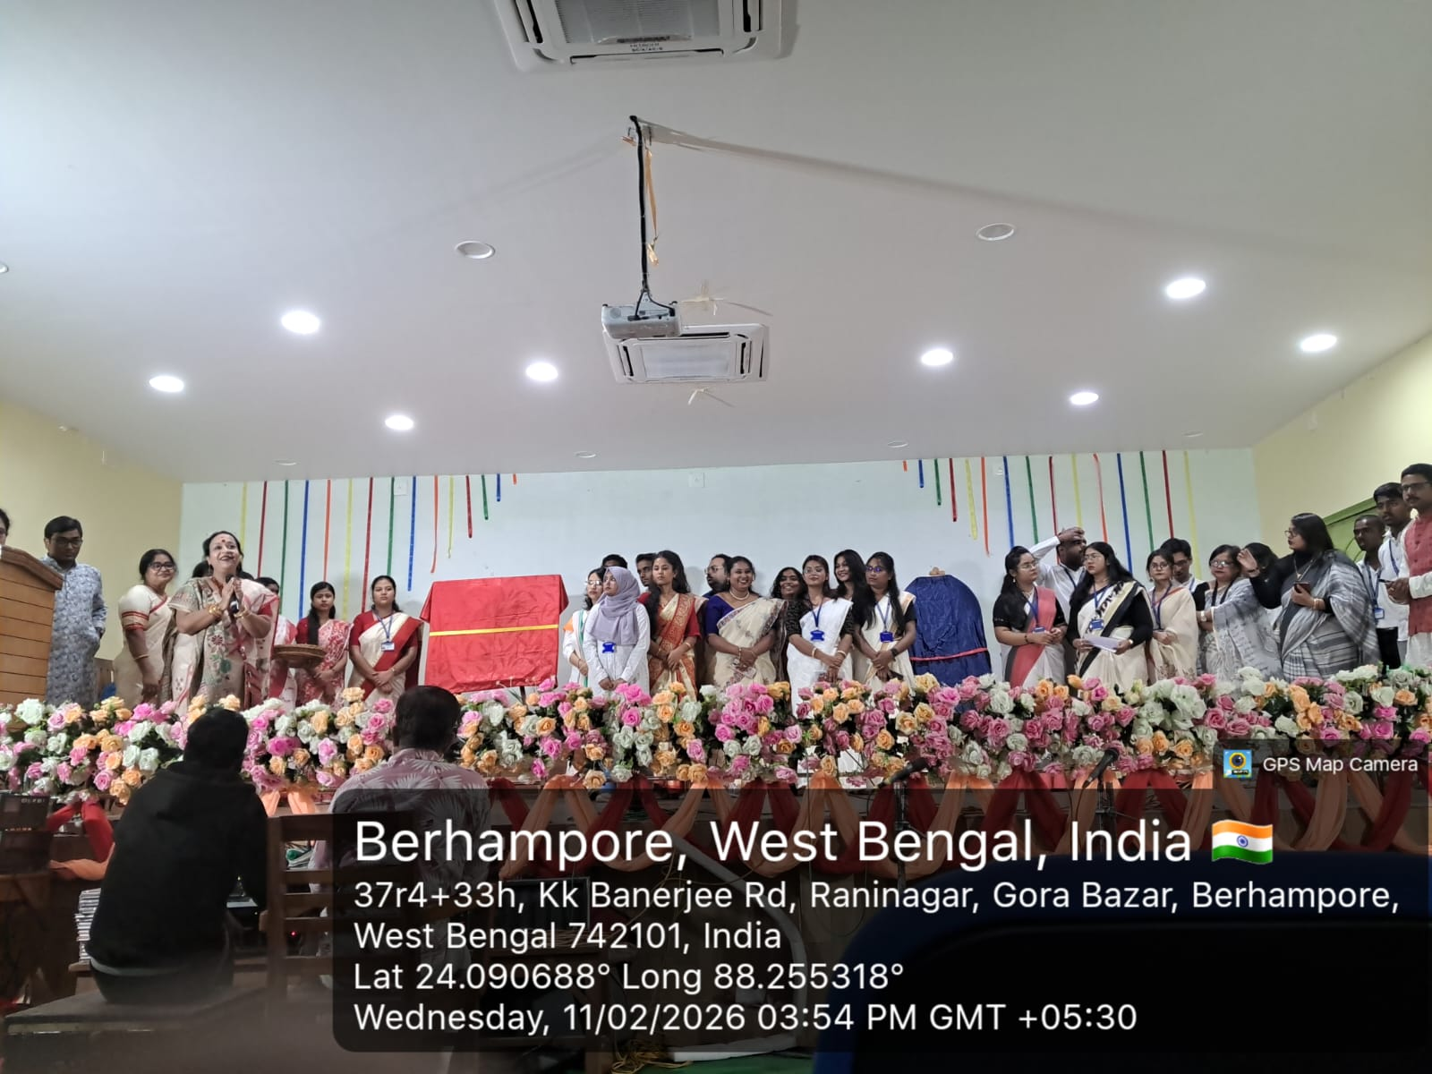

A special highlight of the event was the interactive session of the eminent literary figures- Sir David Lee Morgan, Prof. Subodh Sarkar sir and Dr. Jaydeep Sarangi Sir. They shared the stage and the session witnessed a stimulating exchange of ideas, reflecting on their creative journeys and literary visions. Adding to the charm of the session, distinguished literary figures further enthralled the gathering by reciting their own poetic creations. The audience was spell-bound and greatly captivated by their powerful expressive delivery.
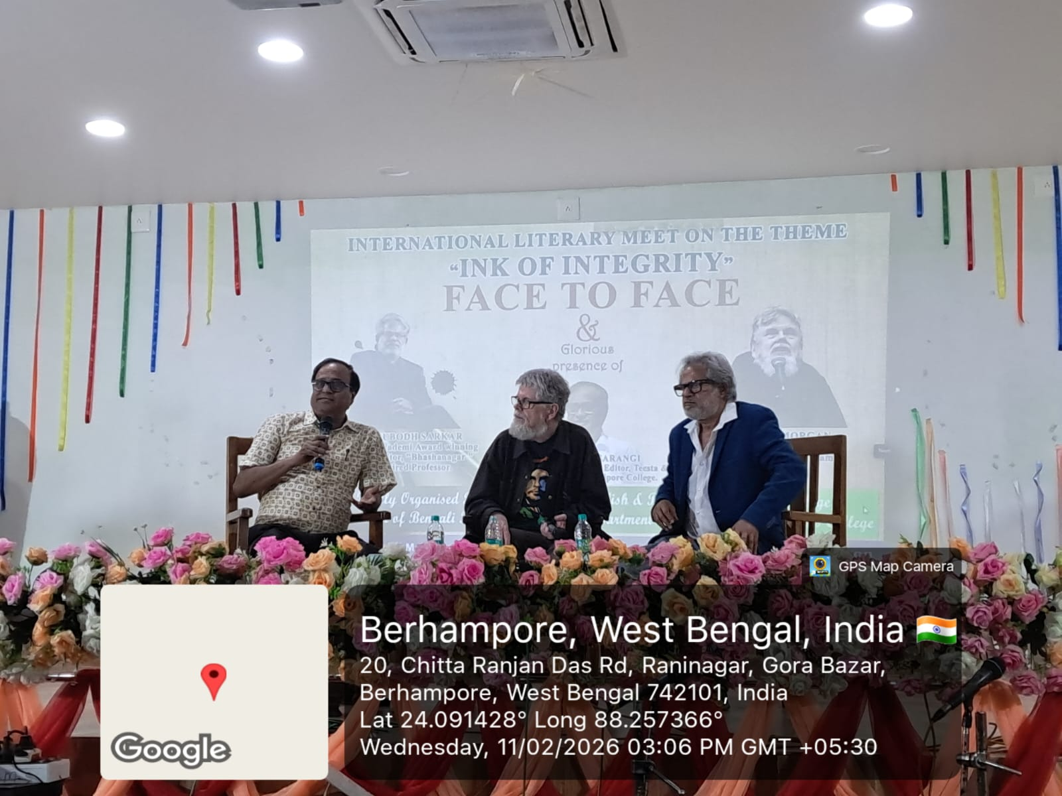
The collaboration between the two departments showcased cultural harmony and academic unity, enriching the overall experience.
The event concluded with a valedictory session and vote of thanks, acknowledging the efforts of organizers and participants. The Literary Meet on the theme” Ink of Integrity” was profoundly inspiring, celebrating the spirit of honest expression and ethical creativity. The event not only provided a vibrant platform for literary exploration but also reaffirmed the timeless truth that words, when guided by integrity, possess the power to enlighten minds and shape society. As the curtains drew to a close, participants and attendees alike carried with them a renewed commitment to let their ink reflect conscience, courage, and conviction.
